​Experiment: Implementation of Shift-Reduce Parser​
​Using C​
​1. AIM​
​To write and execute a C program to implement a Shift-Reduce Parser for the given​​grammar and display SHIFT, REDUCE, and ACCEPT operations during parsing.​
​2. ALGORITHM​
​1.​ ​Start the program.​
​2.​ ​Define the grammar rules.​
​3.​ ​Read the input string.​
​4.​ ​Initialize an empty stack.​
​5.​ ​Shift the input symbols into the stack.​
​6.​ ​Reduce​​id​​into​​T​​.​
​7.​ ​Reduce​​T​​into​​E​​.​
​8.​ ​Reduce​​E + T​​into​​E​​.​
​9.​ ​If the stack contains​​E​​and input is empty, display​​ACCEPT.​​10.​​Stop the program.​
​3.PSEUDO CODE​
​START​
​Read input string​
​Initialize empty stack​
​WHILE input is not empty​
​SHIFT input symbol into stack​
​IF stack contains id​
​REDUCE id into T​
​IF stack contains T​
​REDUCE T into E​
​IF stack contains E + T​
​REDUCE E + T into E​
​END WHILE​
​IF stack contains E​
​DISPLAY ACCEPT​
​STOP​
​4.C PROGRAM:​
​#include <stdio.h>​
​#include <string.h>​
​int main()​

​{​
​char stack[100] = "";​
​char input[] = "id+id";​
​int i = 0;​
​printf("Stack\t\tInput\t\tAction\n");​
​while (input[i] != '\0')​
​{​
​if (strncmp(input + i, "id", 2) == 0)​
​{​
​strcat(stack, "id");​
​i += 2;​
​printf("%s\t\t%s\t\tSHIFT\n",​
​stack, input + i);​
​int len = strlen(stack);​
​stack[len - 2] = 'T';​
​stack[len - 1] = '\0';​
​printf("%s\t\t%s\t\tREDUCE T -> id\n",​
​stack, input + i);​
​stack[strlen(stack) - 1] = 'E';​
​printf("%s\t\t%s\t\tREDUCE E -> T\n",​
​stack, input + i);​
​}​
​else if (input[i] == '+')​
​{​
​strcat(stack, "+");​
​i++;​
​printf("%s\t\t%s\t\tSHIFT\n",​
​stack, input + i);​
​}​
​else​
​{​
​printf("Invalid Input!\n");​
​return 0;​
​}​
​if (strcmp(stack, "E+") == 0 && input[i] == 'i')​
​{​
​// Continue parsing the next id​
​}​
​else if (strcmp(stack, "E+E") == 0)​

​{​
​}​ | ​}​ | ​strcpy(stack, "E");​
​}​ | ​}​ | ​printf("%s\t\t%s\t\tREDUCE E -> E+T\n",​
​}​ | ​}​ | ​stack, input + i);​
​if (strcmp(stack, "E+E") == 0)​
​{​
​strcpy(stack, "E");​
​printf("%s\t\t$\t\tREDUCE E -> E+T\n", stack);​​}​
​if (strcmp(stack, "E") == 0)​
​printf("ACCEPT\n");​
​else​
​printf("REJECT\n");​
​return 0;​
​}​
​5.INPUT:​
​Id+id​
​6.OUTPUT:​
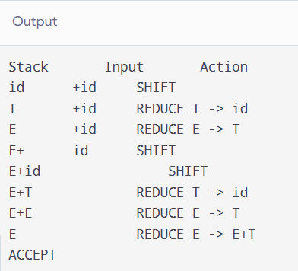

​7.RESULT:​
​Thus, the C program was executed to implement the Shift-Reduce Parser successfully. The​
​input string​​id+id​​was accepted using SHIFT and REDUCE operations.​

